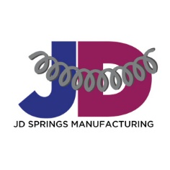  JD Springs Manufacturing  17910 Van Dyke Det Mi 48234  Email: Josiekimball@jdspring.biz  Website: Jdsprings.com  Owner: Josie Kimball (248) 312 – 9188 | CAPABILITY  STATEMENT
Core Competencies
Our company is known for precise and quick turnaround for compression, torsion and extension custom springs: Sample Products and Services – Research & Development, Prototype Design, Engineering, Machine Shop and Fabrication.
Past Performance | Differentiators (bullets)
Hyde Manufacturing Contract Awardee  Motor City Match Awardee  Produced over 10,000 springs | - 1-week turnaround  - 50 years plus experienced technicians  - Customizations  - 0.12 – 2.50 Wire Diameter
Company Data | List Pertinent Codes
JD Springs Manufacturing is privately held founded in 2019 as the 1st Generation in the Spring Manufacturing Industry providing precise craftmanship in our spring products as new start up. | - Special Certifications: WBE 2000984  - Special Certifications: WOSB 200615  - Dun & Bradstreet (DUNS) 11-706-5860  - NAICS codes for your primary service or product: 332613  - CAGE Code: 8BP36
CAPABILITIES  - Customs Springs  - Compression  - Spring Clip  - Short Hook | - Extension  - Torsion  - Wire Forms  - Grind

